AIM
To simulate the lifecycle stages of UI design using the RAD model and develop a small interactive interface (Login system) using Axure RP.

PROCEDURE
1. Requirement Planning Phase
- Identified the need for a simple Login Interface.
- Defined user inputs:
  - Username
  - Password
- Defined output:
  - Success message after valid login.

2. User Design Phase
- Created wireframes for:
  - Login Page
  - Success Page
- Designed UI elements:
  - Text fields for username and password
  - Password visibility icon
  - “Confirm” button
- Focused on usability:
  - Simple layout
  - Clear labels
  - Centered alignment

3. Construction Phase
- Developed the interface in Axure RP:
  - Added input fields and button
  - Configured interactions:
    - On clicking Confirm, navigate to Success page
- Implemented basic interactivity:
  - Page linking (Login → Success)

4. Cutover Phase
- Tested the prototype:
  - Entered username and password
  - Clicked confirm button
- Verified navigation to success screen
- Ensured proper UI alignment and responsiveness

OUTPUT
- A working prototype consisting of:
  - Login Page
    - Username and password input fields
    - Password visibility toggle
    - Confirm button
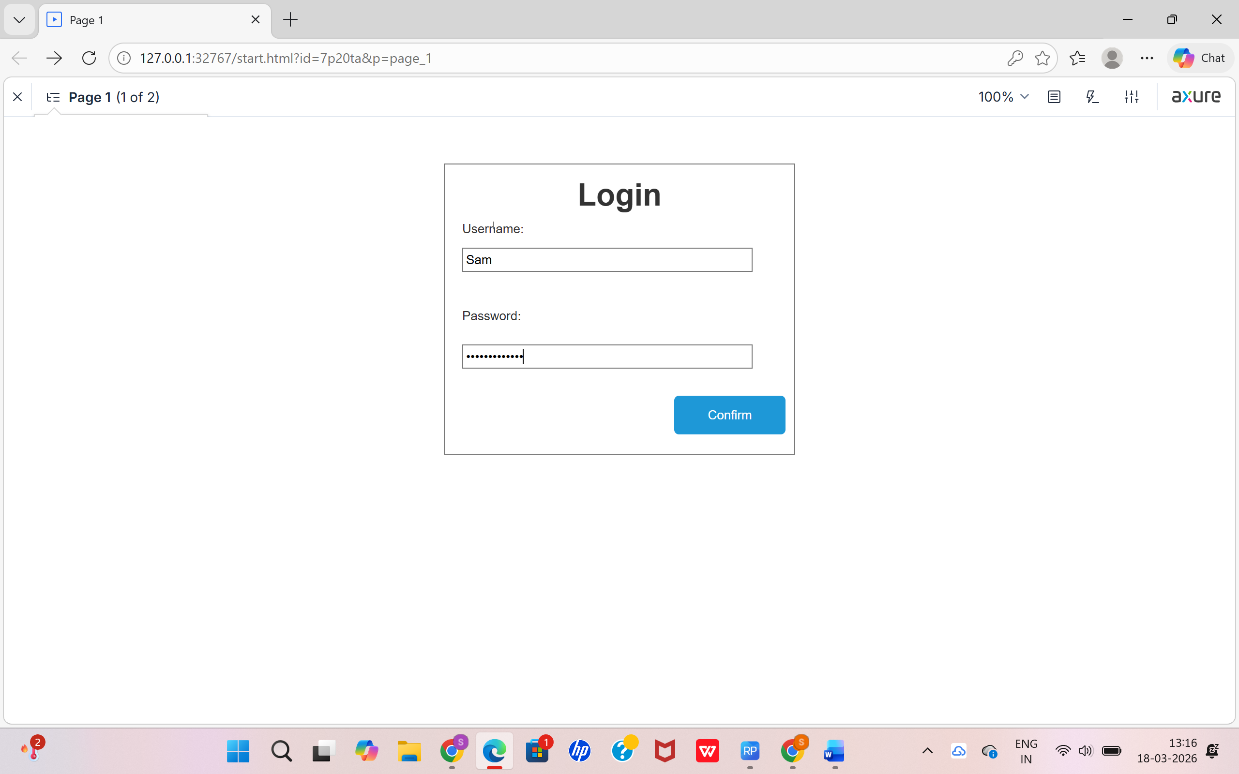
  - Success Page
    - Displays message: “Login Success”
- Interaction Flow:
  - User enters credentials → clicks confirm → navigates to success page
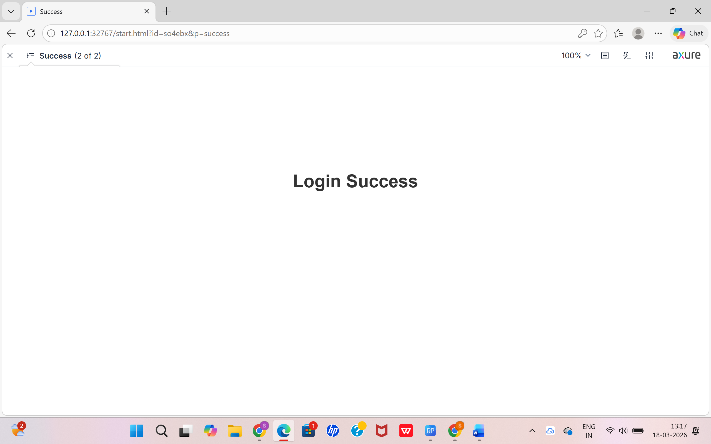

RESULT
The UI design lifecycle using the **RAD

